CNN
Convolutional neural network
- Most powerful
Ex – computer vision, facial recognition, self driving cars or diagnosing medical images

It is a kind of neural network especially designed to handle visual data – images and videos
These are built to recognize spatial hierarchies – edges, textures, shapes – How?
By using filters and convolutions

CNN architectures
- Lenet, AlexNet, VGG, ResNet

100 x 100 pixel image – how many inputs?
10000 inputs
And also images may have spatial structure

Ex – imagine trying to recognize a cat by using pixel values. There’re would a chance of missing whiskers , ears , eyes as patterns
CNN solve this by using local filters and shared weights

Does computer see the visual image as human?
No
Images are arrays of numbers.
Grey scale image – 2D matrix
Color image – 3D tensor (height x width x channels)

For ex – load an image using python code then print the shape ?
Output –
(224, 224, 3)
Each pixel has values – 0 to 255. CNNs treat these as input features.
Convolution
- Its part of CNN
- It’s a mathematical operation that slides a filter over the image to extract features
- Filters are small matrices (ex: 3x3) that detect edges, textures, patterms
Ex – a vertical edge detector might look like
[ [ -1, 0, 1],
[-1, 0, 1],
[-1,0, 1]]
When applied to an image , it highlights vertical lines
The result is a feature map – an image of detected features

CNN architecture
- Input layer (image)
- Convolutional layers (feature extraction)
- Activation layers (ReLU)
- Pooling layers (down sampling)
- Fully connected layers (classification)
Each layer transforms the image in an incremental way of representation
Ex – first layer detects edges, second detects shapes, third detects objects like eyes or wheels etc,

Feature maps
- Feature maps are outputs of convolutional layers
- They show where certain features are present in the image

Training CNN
- Forward pass: compute predictions
- Loss calculation: measure error
- Back propagation: update weights

Keras makes this easy. Define a model, compile and fit to data

CNNs are for image data
CNNs need to detect patterns like edges, shapes, context, objects in images.. - .. need to extract the features
- Convolution
  - Learns filters that detects patterns (edges, corners, shapes)
  - Each convolution operation produces a feature map
- Pooling
  - Reduces size of feature maps
  - Helps in reducing computation and prevents overfitting
- Feature maps
  - Output of layer after applying convolution + activation
Convolution layers = feature detectors
Pooling layers = feature preservers by reducing unnecessary data

Reading an image
- Input form = numeric arrays

Image = pixels
Each pixel stores a number = color intensity
Values lie in between 0 – 255 , 0 means dark, 255 means bright
Channels in color image?
- Red
- Green
- Blue

What is the size(inputs) of a 224 x 224 RGB image?
224 x 224 x 3 = 150,528 inputs
If connected to 1 neuron, one neuron need how many weights?
Approx. – 150K weights
CNN reduce the no.of parameters , by using filters instead of connecting every pixel to every neuron

VGG – visual geometry group

The VGG models were introduced by Karen Simonyan and Andrew Zisserman in their 2014 paper titled "Very Deep Convolutional Networks for Large-Scale Image Recognition."
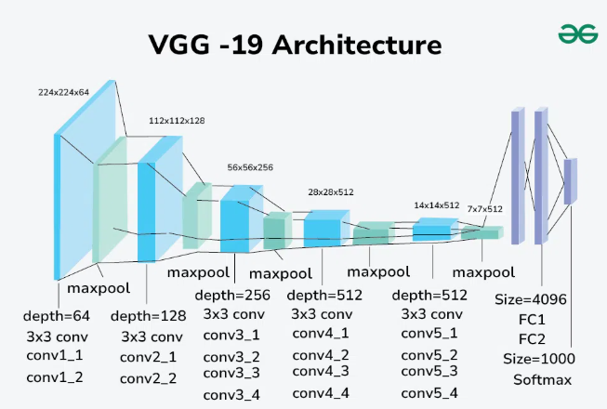

Convolution layers use filters to scan an image, identifying patterns and extracting features like edges, shapes, textures.
Filter / kernel slides over an image(matrix) and perform multiplication + sum to produce an output feature map

Stride
Stride tells how many steps the filter moves each time
Stride = 1 filter moves one step at a time (detailed scanning)
Stride =2 filter jumps two steps (faster, reduces output size)

Ex
Input matrix 4 x 4
[ 1 2 3 4
5 6 7 8
9 10 11 12
13 14 15 16]

Filter 2 x 2
[ 1 0
- 1]

Case A: stride = 1
Filter positions

Step filter covers
- 1 2 / 5 6 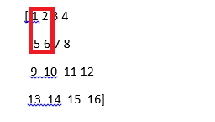

2 2 3 / 6 7
3 3 4 / 7 8
Etc

Output size formula

- { (n – f) / stride } + 1

n = 4 (input size)
f = 2 (filter size)
s = 1
(4 – 2) / 1 + 1 = 3
Output is 3 x 3 matrix

Case B Stride = 2

1 1 2 / 5 6
- 3 4 / 7 8
- 9 10 / 13 14
..

Output size = (4-2)/2 + 1 = 2
Output = 2x2 matrix

Conclusion increasing stride reduces output size

Padding
It means adding extra pixels(usually zeros) around edges so that filter can cover the edge values

Types
Valid padding (no padding) output becomes smaller
Same padding (zero padding) output size stays same as input

Ex
Input matrix 4 x 4
[ 1 2 3 4
5 6 7 8
9 10 11 12
13 14 15 16]

Filter = 3 x3 , stride = 1

Case A no padding (valid)
Output size = (4 – 3) / 1 + 1 = 2
Output = 2 x2

Case b : same padding (pad = 1)
We add one layer of zeros around the matrix
[ 0 0 0 0 0 0
0 1 2 3 4 0
0 5 6 7 8 0
0 9 10 11 12 0
0 13 14 15 16 0
0 0 0 0 0 0]

Matrix size = 6 x 6
Output size = (6 – 3) /1 + 1 = 4
Output = 4 x4 (same as original input size)

Ex
5x5 image and filter 3x3
With stride=1 and padding = same
Output – 5x5
With stride =2 and no padding
Output 2x2

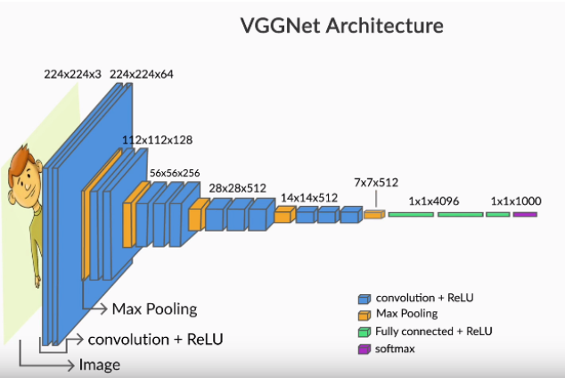

Feature maps in VGGNet
- Input – image of size 224, 224, 3 – 224x224 pixels with 3 color channels
- First convolution layer uses 64 filters, each of size (3,3,3)

After convolution – each output grid is passed through an activation function
Result of activation function is a feature map -
- Since vggnet uses 64 filters in the first layer, it produces 64 feature maps, each of size (224,224)
- Output of first convolutional layer is a tensor of shape (224,224,64)

Trainable parameters
- Each filter has 27 weights (3x3x3)
- With 64 filters, total no.of trainable weights is 64 x 27 = 1728

Filter(3,3,3) – small grid of weights that scans the image
Neuron – equivalent to filter in CNNs
Feature map – output of activation function applied to convolution result

Pooling - ?
After feature maps are generated by convolution + activation , CNNs use pooling layers to aggregate these features
- Max
- Average

Max pooling picks the strongest signal
Average pooling – mean response
- Useful when a smoother representation, but it can dilute strong signals

Pros
- Reduces spatial size
- Lowers no.of parameters
- Improves computation
Cons
- Loses fine grained information
- May discards some sub features
- Less precise
- Can blur

Alternative for pooling
- Use dynamic routing instead of pooling to decide which features to pass forward

For example
Input an image – 6x6 gray scale

1 | 1 | 1 | 0 | 0 | 0
1 | 2 | 2 | 0 | 0 | 0
1 | 2 | 2 | 0 | 0 | 0
0 | 0 | 0 | 3 | 3 | 3
0 | 0 | 0 | 3 | 5 | 5
0 | 0 | 0 | 3 | 5 | 5

Use 3 x3 filter
1 0 -1
1 0 -1
1 0 -1

Stride =1
Padding = 0

Perform convolution
- Apply 3x3 filter on top-left corner of the image
Patch1
1 1 1
- 2 2
1 2 2

Multiply element – wise and sum

(1x1)+(1x0)+(1x-1) +(1x1)+(2x0)+(2x-1)+(1x1)+(2x0)+(2x-1) = (1+0-1+1+0-2+1+0-2) = -2
First feature map value =-2

Next – do it for next sliding patch
1 1 0
- 2 0
2 2 0
Apply filter
(1x1)+(1x0)+(0x-1)+(2x1)+(2x0)+(0x-1)+ (2x1)+(2x0)+(0x-1) = 5
Second feature map = 5
<<do rest of the patches>>
ReLU = max(0,x)
So negative values become 0
-2 becomes 0
5 becomes 5

Apply max pooling
- Pooling reduces size, keeps strongest feature
Ex – 2x2 block
- 5
4 3

Max = 5

Layer1 convolution (filters) feature map
Layer2 ReLU activation removed negatives, keep imp signals
Layer3 max pooling reduced dimension, keep strongest feature

Output shape
Output = {n+2P – k / S } + 1
n=6
k = 3
P=0
S=1
Output shape 6+0-3/1 = 3 + 1 = 4
Feature map size = 4x4

AlexNet - started the deep learning revolution
- 8 layers (5 convolution + 3 fully connected)
VGGNet – power of depth using simple design

googleNet – introduced efficiency
ResNet – enabled training of extremely deep networks using skip connections

Assignment Mandatory
- Read through technical papers of above groups
- Highlight the differences
- discuss

Transfer learning
- take a pre-trained network (AlexNet / VGG….)
- replace the final layer with new classifier
- fine tune it on dataset

it’s a technique where we take model trained on one task and resuse it one a different

https://stats.stackexchange.com/questions/185853/why-do-we-need-to-normalize-the-images-before-we-put-them-into-cnn

https://datascience.stackexchange.com/questions/13636/neural-network-data-type-conversion-float-from-int

augmentor
it’s a python library used to automatically generate additional training images by applying image augmentation techniques like
- rotation
- flipping
- zooming
- cropping
- color modification..

aug1.rotate(probability=0.7, max_left_rotation=10, max_right_rotation=10) rotates image randomly -10 and + 10 degrees

- limited training data - underfitting
- CNN sees images repeatedly model memorizes – overfitting

